**Day 2 – Web Server (Software)**

**Warm-Up Activity**

Creating a simple Web Page

1. Use the Windows File Explorer tool to open your student id folder on the G drive
2. Right click and select New->Text Document
3. Name the file “mywebpage.txt”
4. Edit and save the file with the following contents

<h1>Hello Everybody</h1>

<p>This is a basic <b>HTML</b> web page</p>

Opening your web page

1. Open your web browser (e.g. Chrome)
2. Type “file://G:/” for the URL. What do you see?

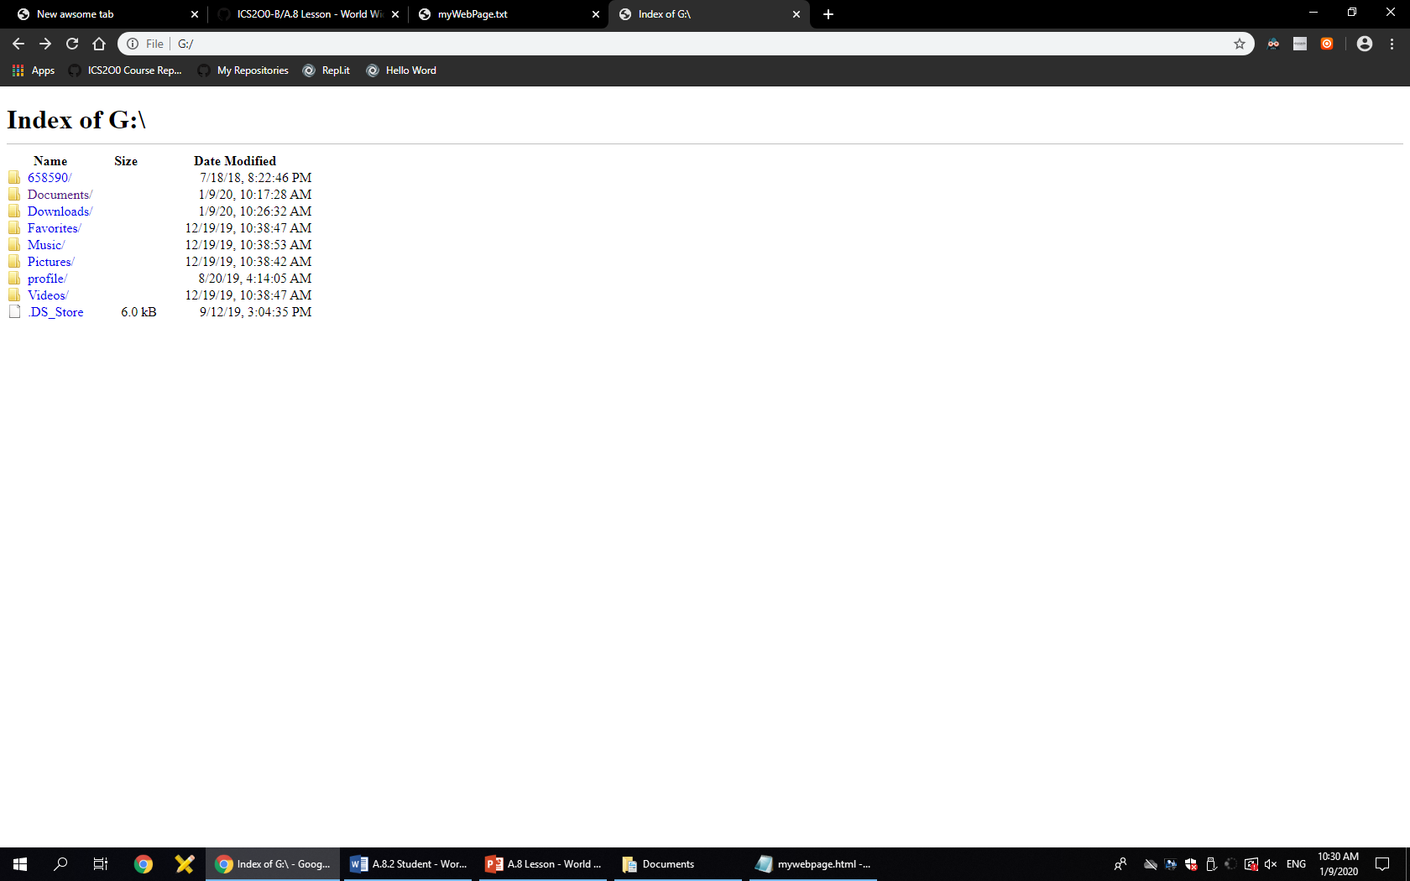

1. Click on your “mywebpage.txt” to open it. What do you see?

<h1>Hello Everybody</h1>

<p>This is a basic <b>HTML</b> web page</p>

1. Use File Explorer to rename your file to “mywebpage.html”
2. Refresh the “file://G:/” URL
3. Click on your “mywebpage.html” to open it. What do you see?

**Hello Everybody**

This is a basic **HTML** web page

**Presentation Notes: Web Server Software**

1. What is a HTML and what does it stand for?
   1. HTML stands for Hyper-Text Markup Language
   2. It is simple text with special tags in angle <> brackets
   3. Most tags control how the page is formatted
   4. Additional tags allow for graphics and dynamic content
2. What does a basic web page contain?
   1. Contains static content (i.e. text content that does not change when the page is reloaded.)
   2. The page can contain advanced graphics in addition to text.
3. How does a dynamic web page differ from a basic web page?
   1. Are basic web pages that also include dynamic content that may change while the page is loaded or when it is reloaded.
   2. May also include program scripts using JSP, Java, Python, etc.
   3. Dynamic pages include links to include data from other types of web servers (e.g. Streaming Servers, Database Servers, etc.)
4. What is a Web Server?
   1. You could run this program on any PC
   2. Usually runs on more reliable Web Server Hardware
5. What are some functions of a Web Server?
   1. To respond to HTTP or HTTPS internet requests from user clients (i.e. web browsers)
   2. To provide service for basic web pages
6. What are some common types of Web Servers?
   1. Most common web server programs include:
      1. Apache – Unix / Linux
      2. IIS – Microsoft
7. What is a HTTP and what does it stand for?
   1. ***HTTP*** stands for Hyper-Text Transfer Protocol
   2. Your browser (client) wants to connect to a web server
   3. Your browser is expecting to receive HTML content
8. What is the difference between HTTPS and HTTP?
   1. Starting a URL with https:// indicates that..
      1. The same thing as http with the addition that…
      2. Information sent and received is in ***encrypted*** format
      3. ***https*** provides a ***basic level*** of security for passwords and other private information
9. What are some other common URL protocols?
   1. Starting a URL with https:// indicates that..
   2. The same thing as http with the addition that…
   3. Information sent and received is in encrypted format
   4. https provides a basic level of security for passwords and other private information